Summary of our findings: Project #2022-5058
Dear Yoda:
We really appreciate the data of clinical trial ACIS provided by J&J and the continuous support you have provided over the past year. However, as we have previously discussed via email, while the provided database includes the auxiliary medication usage records we are interested in, J&J is unable to provide specific timing and duration of patient medication usage due to the risk of re-identification of subjects. Therefore, we are unable to group patients based on the dosage and duration of the medication of interest, and we cannot perform time-dependent Cox analysis to ensure the scientific validity of the results. We understand the efforts made by J&J to ensure patient privacy, and although we are somewhat disappointed, we appreciate the commitment to protecting patient confidentiality.

Objective: Using individual patient data from ACIS which including patients treated with apalutamide + abiraterone or abiraterone to explore the impact of long-term PPI use on the prognosis.

Methods Used: Participants who received identical treatment will be stratified based on their use of proton pump inhibitors (PPIs) into two groups: long-term PPI users (those who used PPIs before randomization and continued during the treatment process) and other patients. Propensity score methods (PSM) will be employed to mitigate baseline differences among various racial groups. PSM will be implemented using the MatchIt package in RStudio. Subsequently, based on the data after PSM, the Mantel-Byar test and the Simon-Makuch survival plot will be conducted in R, considering the time-dependent nature of PPI usage as a covariate. Finally, a time-dependent Cox model will be established using the survival package. However, given the unavailability of specific time points and durations of PPI usage, the Mantel-Byar test and time-dependent Cox model cannot be performed in this analysis.

Results: Although lacking the necessary time parameters, we conducted preliminary exploratory analysis on the data. Patients were simply categorized into PPI users and non-users based on medication usage records. The results indicated better prognosis among PPI users (Figure 1). It is important to note that this result may be subject to immortal time bias as the timing and duration of PPI usage were not properly adjusted for in the analysis.

Conclusions: N/A

Figure 1
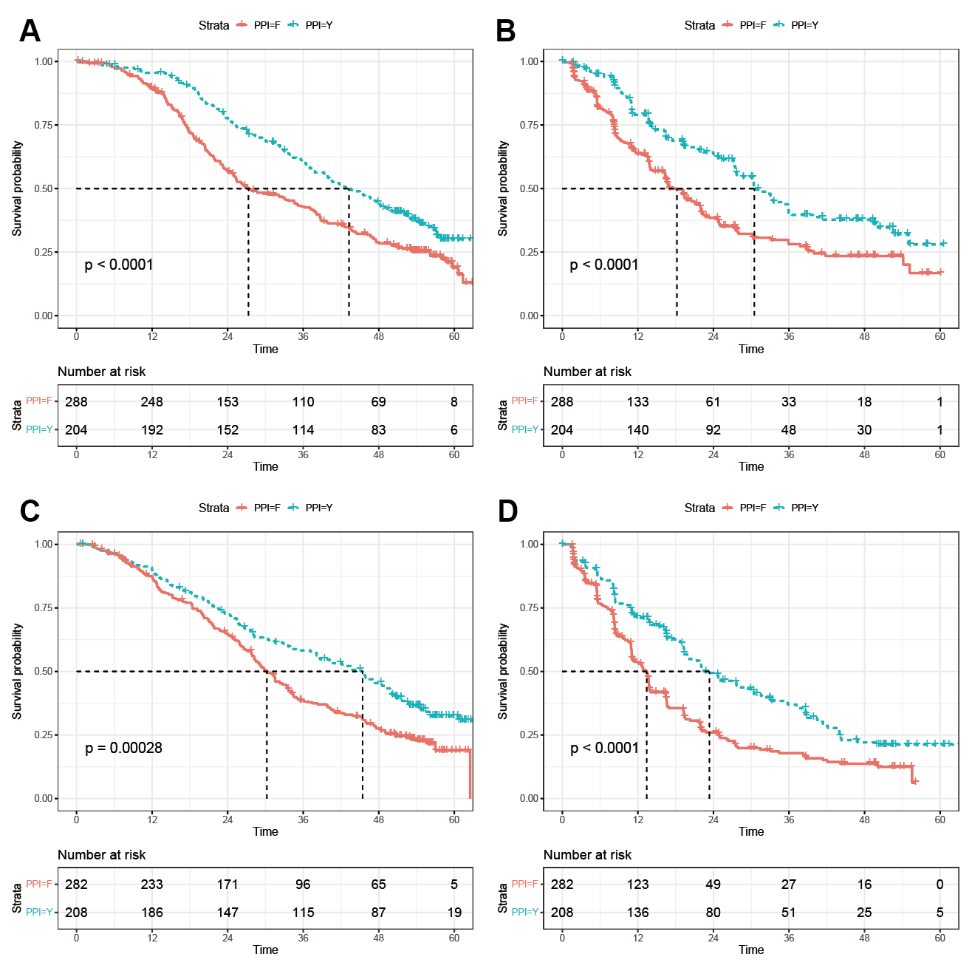
Figure 1. The Kaplan-Meier curve was generated by dividing the patients into two groups based on PPI usage (used PPI vs. never used PPI). (A) OS in apalutamide + abiraterone cohort; (B) rPFS in apalutamide + abiraterone cohort; (C) OS in abiraterone cohort; (D) rPFS in abiraterone cohort.

